# Lab 1 - DAVE3625-1 23H Introduksjon til Kunstig Intelligens

Most of the time spent working on AI, is actually time spent preparing data. You need to figure out what datapoints to use, and if you can combine datapoints to get a better model.

The first task when working with a new dataset is to clean the data and solve data errors. In the file stud.csv, we have 50 entries with:

StudentID, Age, email, hrsStudy, FinalGrade

In this lab, you will import the csv file into pandas:

Hint:   
df = pd.read_csv(url, sep=',')

df.head()

You will then clean the data set so df.info() produce

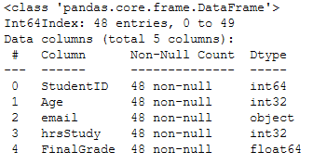

Hint:

df.isna().sum() #show missing values  
df=df.replace(r'^\s*$', np.nan, regex=True) #Replace blank values with np.nan values

df['Column'] = df['Column'].astype(str).astype(int) #Convert from obj to int

Then idenify and remove the outliers in the «FinalGrade» column

Hint : df["FinalGrade"].plot.box()

Finally add a column “Grade” where you transform the grade from float to a char:  
91 - 100 = A  
81 - 90 = B  
71 - 80 = C  
61 – 70 = D  
51 – 60 = E  
> 50 = F

And produce this plot: